USER GUIDE

Search MEdication types

September 2018

Version 1.02

Pharmacon ITC303/309 Group

Document Revisions

|  |  |  |
| --- | --- | --- |
| Date | Version Number | Document Changes |
| 30/08/2018 | 1.01 | Draft |
| 15/09/2018 | 1.02 | Initial |
|  |  |  |
|  |  |  |
|  |  |  |
|  |  |  |
|  |  |  |
|  |  |  |
|  |  |  |

Table of Contents

1 Introduction 4

1.1 Scope and Purpose 4

1.2 Process Overview 4

2 Search Medication Types 5

2.1 Login – Administration User 5

2.1.1 To Log in to Pharmacy Error Tracker (PET): 5

2.2 Search Medication Types 6

2.2.1 Navigate to Search Medication Types 6

2.2.2 Search Medication Types 7

2.3 Medication Type Update 8

# Introduction

## Scope and Purpose

The purpose of this user guide is to provide instructions on how to search for a medication type that has already been entered.

No other features of the Pharmacy Error Tracker (PET) application will be discussed in this user guide.

* To be able to use PET, the user will need basic knowledge of logging into an online application and using a search function to locate records.
* This feature is only available to a user with administrator rights.

## Process Overview

The administrator will need to log into PET using their valid username and password.

* The Welcome Page will be presented on successful login.
* The administrator will need to select Search Medication Types via the menu bar or the button on the menu page.
* The user is to enter a search criterion.

# Search Medication Types

To search for a medication type, the user will need to launch the application, login with a valid user name and password with administration rights. Using the search bar, the user will be able locate a medication type or multiple medication types relating to the search criteria entered.

## Login – Administration User

User must have access to the application.

User must have a valid username and password with administration rights.

### To Log in to Pharmacy Error Tracker (PET):

1. Launch the application.
2. Click in the Username field.
3. Enter username.
4. Tab or click in Password field.
5. Enter password.

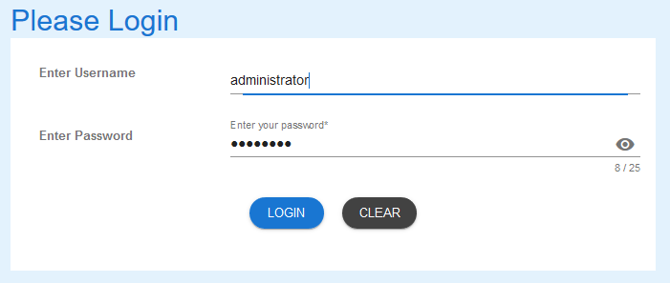

1. Select LOGIN to access PET.

NOTE:

Users entering an invalid username and/or password will not beable to access PET.

## Search Medication Types

### Navigate to Search Medication Types

1. From the Welcome Page, there are two ways to navigate to “Search Medication Types”:
   1. Select the “Search Medication Types” from the list

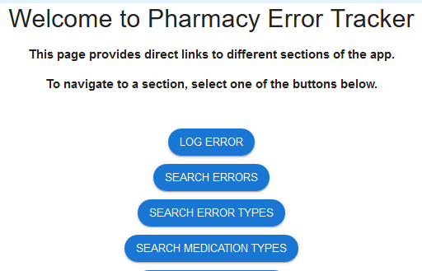

* 1. From the Menu Bar, hover your mouse over “Search…” and select “Search Medication Types”

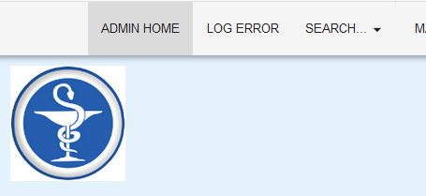

1. A list of medication types in the database will appear, showing the first five (5) entries.

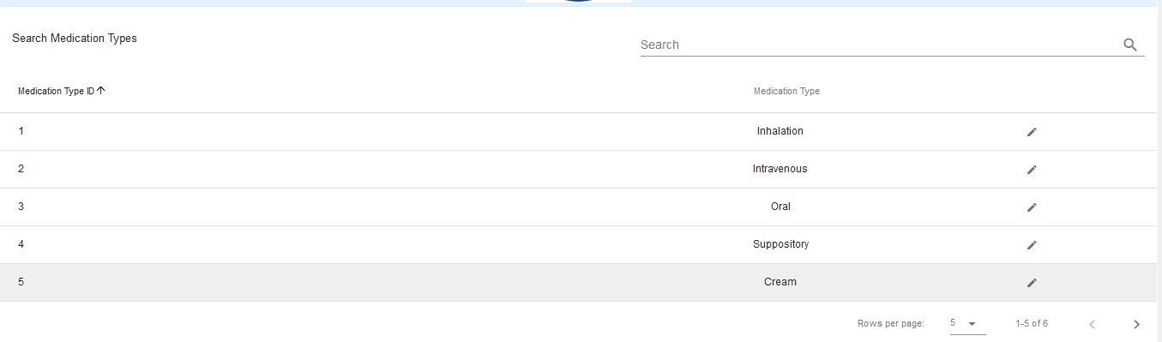

* 1. To change the number of records being shown, click on the drop-down arrow at the bottom-right corner and select number of records you wish to see.



### Search Medication Types

1. To search for a specific record, enter the criteria in the search field located at the top-right corner.



1. The search criteria entered will find any record that matches that criteria in the fields shown in the headings. Entering a more detail criteria will narrow the number of records that are returned. Entering “i” returns 3 records of those available.  
     
   By entering “in” the search is narrowed further.

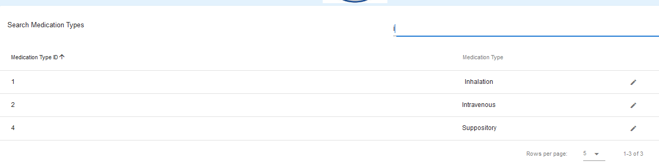

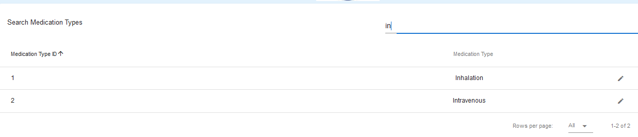

1. To search for another medication type record, repeat from step 1.

## Medication Type Update

Medication types can be loaded into the Medication Type Details form from a search, be amended and the record in the database updated. Please see the **User Guide - Update Medication Types** for instruction.

If you encounter issues not addressed by this user guide, please contact your account manager for additional support.